January 3, 2018

Dear Friends:

Representing Maine in the United States Senate is an honor.

I continue my work on the Senate Armed Services Committee, each year authorizing the funding required to build our military capabilities and ensuring that are service members are trained and equipped to defend our nation. I was pleased to be part of a bipartisan effort to enact a new law to simplify the appeals review process to reduce the backlog our veterans are facing, as well as a new law that provides critical funding to the VA Choice Program, allowing veterans in rural Maine to access services closer to home.

While my committee work is important, working to combat the opioid epidemic is one of my top priorities. Although Congress has made some important strides, much remains to be done to provide additional funding for prevention, treatment and enforcement. I am working with colleagues on both sides of the aisle to pressure the Drug Enforcement Administration to reduce the amount of opioids produced and to thwart the flow of fentanyl and other deadly drugs into our country.

I am very optimistic about the integrated, multiagency effort I led with Senator Collins to foster innovation and commercialization in Maine’s forest economy. Through the Economic Development Assistance Team (EDAT) we are already experiencing increased federal investments that will strengthen our existing forest products industry and help support job creation in rural communities. Initiatives like Cross Laminated Lumber, Combined Heat and Power, manocellulose, ED printing with biobased materials and other biobased products will mean that Maine’s wood-basket will continue to be a major jobs and economic contributor for our future.

Finally, the coming year will continue the work of the Senate Select Committee on Intelligence in the ongoing investigation of Russian interference in the 2016 election. Our Committee has held seven public hearings and numerous classified sessions, reviewed tens of thousands of pages of documents and conducted hundreds of interviews. I remain focused on the security of our elections and committed to developing strategies to prevent interference by foreign governments in our democracy.

May 2018 be a good year for you, your family, your community and our great State.

Best,
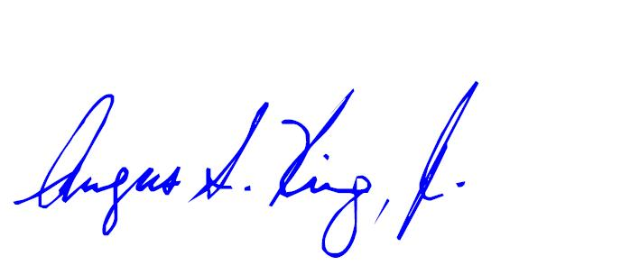

Angus S. King
United States Senator

